Participant-Centered Adherence Counseling Guide
for
MTN-017

Developed by

Iván C. Balán, Ph.D.
and the
Behavioral Research Team
at the
HIV Center for Clinical and Behavioral Studies
Columbia University

Initial Period Visit
(Visits 2, 5, & 8)

OVERVIEW OF SESSION

The purpose of this session is to orient the participant to adherence counseling and reinforce the value of accurate reporting of adherence to study product use.

This is the session that will establish the client-centered spirit of the counseling sessions, thus the counselor should focus on building a relationship with the participant, affirming their willingness to take part in the study, and the appreciation for their role in helping the researchers understand how these products might be used by the community.

OUTLINE OF INITIAL PERIOD SESSION

- Welcome participant to the session

- Provide overview of adherence counseling
- To discuss your experience in using the product
- To ask you to help us come up with the most accurate estimate of how many times you used the product using the reports from SMS, returned products and your bloodwork levels
- Not to push you to use the product or to make you feel bad if you were not able to use it exactly as asked.

- Review focus of session
- To explore the participants plan for using the product over the next 8 weeks
- To identify and plan for any obstacles to using the product

- Gauge the participant’s understanding of product use
- How were you told that you should use this product, for example how often or when?

- Assess confidence of using the product as indicated (Appendix 1)
- On a scale of 0 to 10, where 0 is not at all confident and 10 is extremely confident, how confident are you that you will be able to use the product as instructed?
- What might help move you from a __ to a __ (two numbers higher)?

- Identify potential obstacles to product use (Appendix 2)
- So, as you think about using this product, what might make it difficult for you to
use the product as was indicated? What else?
- What could you do to minimize the impact of this on your use of the product?
- What else could you do if that doesn’t work?

- Close session
- Summarize session
- Review what will happen during next session
- Explore the experience of using the product over the next 4 weeks
- Review and converge the product use reports from SMS, product return, and PK results
Step 1: WECOME PARTICIPANT

Goals: To affirm participant’s attendance at the session

Example: Well, first of all, thank you for taking the time to come in for your
appointment, as you know studies are dependent on their participants showing up for the appointments, so I really appreciate your commitment to following through with the study.

Step 2: PRESENT OVERVIEW OF PRODUCT ADHERENCE COUNSELING

Goal: To inform the participant about the counselor’s role and provide an
overview of what will occur during the adherence counseling sessions.

Approach: The counselor provides an overview of their role in the study and
adherence counseling and stresses the importance of accurate reporting of experiences. This is stressed more than using the product as indicated. This is done so that the participant feels more comfortable reporting problems with adherence.

KEY POINTS:
Purpose of adherence counseling is to:
- Understand the participants experience using the product

- Have the participant help us decide the most accurate
number of times the product was used.

Example: My name is __________________ and I will be meeting with you each
time you come for a study visit in order to discuss how things have gone for you using the study products, whether it’s the pill or the gel. During our visits we usually review how you have used the product. A very important part of our meetings is to get an accurate idea of how regularly you have used the product. For some participants, using the product regularly is not as easy as they thought, so in these sessions we just want to hear how it has gone for you, whether it has gone well or not and whether you have been able to use the product regularly or not. We learn a lot from people who use the product and from those who do not, so an accurate report is very helpful to us! And, if you were having problems in using the product and were interested in hearing how others have dealt with similar problems, I will be happy to share those ideas with you in case you want to try them and see how it goes. My role is NOT to convince you to use the product more regularly, but to really learn from you about how it is going and, if you think it will be helpful, work with you to figure out ways to use it as regularly as possible.

As you know, there are three different Periods in the study. We will meet at the beginning, middle, and end of each period.

What questions to you have for me up to this point?

Step 3: SET STRUCTURE FOR SESSION

Goals: To give the participant an idea of what will occur during this session.

Approach: The counselor provides an overview of what will happen during the
session.

Example: The plan for today’s meeting is to discuss using the gel (or taking the
pill) over the next 8 weeks, how you anticipate that going for you, and if there are any obstacles that you can think of that might impede your ability to use the product regularly. How does that sound?

Step 4: ASSESS PARTICIPANT’S UNDERSTANDING OF PRODUCT USE

Goal: To assess whether the participant accurately understands how they should
be using the product during their current study period.

Approach: The counselor asks the participant for their understanding of how
they should use the product they were given during the next four weeks. If there are minor inconsistencies or questions, the counselor can provide the accurate information. BUT, the counselor should NOT take on the role of the clinician. Thus, if the participant is unclear about how/when to use the product or has a number of questions regarding its use, the participant should be referred back to the clinician for clarification.

KEY QUESTION:

How were you told that you should use this product, for example how often or when?

Example: So, today you will start the first Period of the study and you will be
given (pill or gel) to take home with you. So, how were you told that you should use this product, for example how often or when?

Great! So you are pretty clear on what to do. The only thing that I want to clarify is that you can indeed change the time during the day that you take the pill. You should take it at more or less the same time every day, but it doesn’t have to be in the morning. So you can decide when during the day you want to take it and we can work during this session to help you figure out what a good time might be for you. Okay?

Step 5: ASSESS CONFIDENCE OF USING PRODUCT AS INDICTED

Goal: To gauge how confident the participant feels about using the product as
indicated.

Approach: The counselor will use a confidence ruler (see Appendix 1) ranging
from 0 to 10 and ask where the participant is on that spectrum.

Example: Okay, so thinking about how you were asked to use the product and
about your typical day and week, and everything else you have going on in your life, I would like you to indicate for me on this sheet how confident you feel you will be able to use the product as was indicated; 0 is not confident at all and 10 is completely confident. Where along this line are you?

If 7 or above: Ask participant to describe their plan for using the product regularly.

Example: Sounds like you are pretty confident that you will be able to use the product as indicated.
- What plan do you have in place to do so?
- What are you going to do to help you use the product regularly?

If 7 or below: Explore with the participant what would help them increase their confidence that they will use the product regularly.

Example: Sounds like you are somewhat sure that you will be able to use the product as indicated, but you are not too sure. Let’s talk a bit about what might keep you from using the product regularly and what you might do about it. Okay?

Step 6: IDENTIFY POTENTIAL OBSTACLES TO USING
THE PRODUCT AS INDICATED

Goal: Help the patient identify and problem-solve obstacles to using the product
as indicated.

Approach: Using Appendix 2 as a guide, the counselor inquires about obstacles to
adherence and then works with the participant to identify possible solutions to overcome the obstacles. The counselor first tries to have the participant identify ways to overcome the obstacles, only offering suggestions after the participant appears to not have any. Prior to making recommendations, the counselor should ask the participant if he wants some thoughts on how to deal with a particular obstacle. At the end of this section, repeat back to the participant the plan that they developed.

KEY POINT

When developing solutions for using the product consistently, FIRST as the participant for what they might do. AFTERWARDS, offer to provide with participant with some suggestions.

Example: So, as you think about using this product, what do you think might
make it difficult for you to use the product as was indicated? What else?

Okay, so you can imagine a couple of things making using this product as indicated a bit difficult. Should we take some time to think how to overcome these?

So the first thing you mentioned is…..
What are some things you can do to minimize the impact of this on your use of the product? Let’s see if we can come up with two or three solutions for each obstacle. What else might you do if that doesn’t work?

Okay, now let’s go on to the next obstacle you mentioned, which was…

Sounds like you are not sure how to overcome that obstacle. If you would like, I can offer you some suggestions. Is that okay?

Great, thanks so much for thinking through some of this with me and figuring out what you can do to use the product regularly. As you think about using the product, are there any other questions that you have?

Okay, the your plan to use the product consistently is to…(repeat the plan that the participant developed)

Step 7: CLOSE SESSION

Goal: To review session accomplishments and remind participant that he will
have these sessions when he comes back for the mid-period visit.

Approach: The counselor affirms the participant’s engagement in the session and
in the study and provides an overview of the mid-period session.

KEY POINTS:

Describe what will happen in the next counseling session
- Explore the experience of using the product over the next 4 weeks
- Review and converge the product use reports from SMS, product return, and PK results

Example: Okay, so we are done for this visit. Thanks so much for coming in and
thinking through what using the product will be like for you and potential problems that will come up. I think you came up with a good plan for using the gel (taking the pill) regularly. When we meet in 4 weeks I will ask you about how things went with the plan, is that okay? As you know, during the study we will be keeping track of your product use in a number of ways: your SMS text reports, the pills or applicators you return, and through your bloodwork which lets us assess the level of medication in your system. During the next session, we will review reports from your SMS texting, your returned applicators, and your bloodwork so we can work together to figure out the most accurate estimate of your product use. How does that sound?

Okay, so I will see you in approximately 4 weeks!

Mid-period Visit
(Visits 3, 6, & 9)

OVERVIEW OF SESSION

The aim of this counseling session is for the counselor and participant to work together to decide the most accurate count of how many times the product was used, and explore the participant’s experience using the study product (pill or gel) as indicated in the protocol, their willingness to improve their adherence to the product, and ways of improving their adherence if they wished to.

It is important for the counselor to remember that there are many reasons why the product use counts based on product return, SMS reports, or PK may not accurately reflect how many times the product was used. For example, the count based on the product returned may not be accurate because: 1) the participant may not have remembered correctly how many pills or applicators he left at home (or at a boyfriend’s house); 2) They may have shown a friend how the applicators work, so they would not have returned the applicator but it was not inserted rectally; 3) the participant might have given a friend some of the pills; 4) the participant might have had problems inserting the gel and used 1 or 2 applicators in the process, or 5) other issues. Similarly, the product use count based on SMS may be inaccurate due to: 1) problems texting; 2) losing one’s phone; 3) going away and forgetting to take one’s phone; 4) confusion about using the SMS reporting system; or 5) other issues. Lastly, the PK level, which will only say “positive” or “negative” may not accurately reflect product use if: 1) the blood sample was compromised in some way; 2) the participant used the product regularly at the beginning of the four weeks, but not during the few days prior to the study visit; 3) or other reasons.

So, it is important for the counselor to remain neutral regarding the participant’s product use so that the participant will not feel judged for imperfect adherence. The tone of the session is that the counselor and the participant will work collaboratively to see how the participant is doing with the product use. So, instead of focusing on affirming the participant’s high adherence, the counselor will focus on affirming the participant’s attempts to report product use accurately, even if it is not fully adherent.

In discussing product use, the counselor should avoid “pushing” the participant, even gently, to use the product more frequently since this may create discomfort in the participant reporting non-adherence accurately. Towards the end of the session, and only if the participant indicates that he wants to use the product more regularly, should the counselor work with the participant to figure out ways of doing so.

OUTLINE OF MID-PERIOD SESSION

- Welcome participant, set structure for session

- Review and converge adherence data
- I am going to ask you to help us figure out the most accurate estimate of
how many times you used the product
- Which of these (i.e., SMS, returned product count) do you think best represents the actual number of times you used the product. Why?
- Is this number completely accurate, or do we need to adjust it up or down?

- Converge PK level with PRIOR product use reports (Visits 6 & 9)
- Now I would like you to help me do something similar, but using the results of
your bloodwork.
- Last time, you reported using the product XX times. Now, the bloodwork does
not show any product in your system. Why do you think that might be?

- Explore what helped participant adhere to product use
- It’s great that you were able to use the product over the past four weeks!
- What helped you use it on those occasions?

- Assess participant’s thoughts on current adherence
- What are your thoughts about your product use to this point? (Appendix 5)

- Explore ways to improve adherence (if indicated by participant)
- What are some of the obstacles that came up that kept you from using the
product more regularly?
- What might you do to overcome this obstacle? What else?

- Close session
- Summarize session
- Review what will happen during next session
- Explore the experience of using the product over the next 4 weeks
- Review and converge the product use reports from SMS, product return, and PK results

STEP 1: Welcome participant and set structure for session
Goals:
- To affirm participant’s attendance at the session and inform the participant of what will occur during the session.
- To normalize difficulties with adherence to product use as specified in the protocol

Approach: The counselor uses a client-centered approach to welcome the
participant back for another visit and affirms the participants continued interest and commitment to the study. Then, the counselor offers an overview of what will occur during the session.

Example: Well, first of all, thank you for taking the time to come in for your
appointment, as you know studies are dependent on their participants showing up for the appointments, so I really appreciate your commitment to following through with the study.

During our time together, we are going to be discussing how it has been going for you in terms of using the gel (or taking the pill) over the past few weeks. You have been reporting on using the gel (or taking the pill) through text messages and by the unused gel applicators (or pills) that you returned. We will also look at the reports from your bloodwork that assess how much product is in your system. Oftentimes, these reports give us different information so I am also going to ask you to help me figure out which of these reports you think gives the most accurate information about how you used the gel (or took the pill). And lastly, I am going to ask you about how you feel about your use of the gel (or taking the pill) and if there is anything you would like to do about it. How does that sound?

Step 2: REVIEW ADHERENCE REPORTS AND REACH DECISION
ON FINAL NUMBER OF TIMES PRODUCT WAS USED

Goal: To reach most accurate estimate of product use adherence

Approach: The counselor uses Appendix 3, the reports from the text messages
and the applicator (or pill) counts, and the calendar of product use (Appendix 4) over the past 4 weeks to guide the discussion of which is the most accurate report of product use adherence. The counselor should avoid confronting the patient regarding the differences in the reports, instead normalizing the fact that there are differences and exploring with the patient, which reporting system they believed yielded the most accurate reporting and, eventually, reaching a decision on the number of occasions that the gel was used (or pill was taken). Afterwards, the counselor affirms the participant for their help in providing the most accurate measure of their product use.

KEY POINT:
Mention to the participant that:

- We KNOW that product use reports from the SMS, returned product count, and PK levels may be different

- We would like their help in figuring out the most accurate count of how many times they used the product

Example: As you know, we are keeping track of how you use the gel (or take the
pill) through the text message and through the gel (or pills) that you return. I have those reports here. We know that these reports will not be consistent, they are not perfect counts of how you use the product. So, I would like to take some time for you to help me understand which of these reports you think give the most accurate estimate of how many times you used the product since your last visit. So, can you help me figure that out? Great!

One more thing. I just want to remind you that we know that it can be difficult to use the gel (or take the pill) consistently the way we have asked you to use it. We know that. So, if you were not able to use the gel (or take the pill) consistently, we understand. And we will ask you about what makes it difficult to use the gel (or take the pill) consistently, that is also really important for us to understand from your experience. But, what becomes really important at this point, though, and we really appreciate your help in this, is you helping us get to the most accurate estimate of how many times you used the gel (or took the pills). Okay?? Great, then let’s get started.

So, based on your text message reports, it seems you used the gel (took the pill) XX times over the past 4 weeks. Based on the applicators (pills) you returned, it seems you used the gel (took the pill) XX times during the past 4 weeks. We also have a calendar that we have created about your product use based on the SMS reports which can help us figure out the final count of product use.

Of these measures (SMS and applicator return counts):
- Which do you think is the most accurate?
- What makes that measure more accurate than the others?

Regarding this measure, the one you think is the most accurate, how accurate do you think it is in representing the actual number of times you used the product?

Okay, so it is more accurate than the other measures, but you still find that it’s not completely accurate.
To make it more accurate:
- Would increase this number, decrease this number, or leave it just like that?
- Why?
- So what number would you put here that you think would be the most accurate representation of the actual number of times you used the product?

As you look at the differences in these reports, to what do you attribute the difference?

MAKE SURE TO AFFIRM THE PARTICIPANT’S HELP IN REACHING THIS NUMBER !!

Okay, so that is the number that we will put here. Thanks so much for your help in trying to figure this out, getting this accurate information is super important to the study. Thanks again.

Step 3: REVIEW PK LEVELS &
CONVERGE WITH PRIOR PRODUCT USE REPORTS

NOTE: This Step is done in visits 6 & 9, but not in visit 3. Also, it is not done during the RAI-dependent period.

Goal: To understand discrepancies between PK levels and reported product use

Approach: As is done with the convergence interview, the counselor shows the
participant the product use report and calendar from the previous study visit since that will coincide with the PK report from blood taken during that visit. The counselor also shares with the participant the results from the PK reading (Appendix 6), which will state whether there is evidence of PK in their system. The counselor needs to keep in mind that an absence of PK in the system is NOT indicative of a participant being totally non-adherent. Thus we need to understand the story behind the PK levels and the product use reports, especially if there are discrepancies.

Although the counselor explores discrepancies between the product use reports and PK levels, the counselor should NOT change the old product use reports.

Example: Okay, now I am going to ask you to do something similar to what we
just did, but look back a bit further. This is the product use report that we completed last time, remember? It covers the first (or last) four weeks of this (or last) study period. I also have here the calendar of your SMS reports for that period. And, here I have the bloodwork report from the sample that was taken during your last study visit and covers the same time period as these reports. So, just like we just finished doing, I want you to help me understand the story behind these numbers. According to the SMS and applicator counts it seems that you used the product XX number of times. And, this blood level suggests that there is no medication in your system. We know that there can be different reasons for this, but help me understand why this might be the case for you. Why do you think that might be? We also have the calendar of your product use here in case it is helpful for us in understanding these results.

If the PK results were negative, but the participant used the product during that period, a statement like the one below can be useful in closing the discussion.

So, as you reported during the last session, you were able to use the product 20 times during the that 4 week period, but based on this negative PK result, that might not have been sufficient for there to be enough product in your system to be detected by the bloodwork. That would make sense.

Lastly, make sure to thank the participant for their help in figuring out the story behind the numbers.
STEP 4: Explore what has helped participant adhere to product use

Goal: 1) To highlight successes in product adherence to help boost the
participant’s self-confidence that he will be able to continue using the product regularly; 2) To help the participant figure out what they do that helps them use the product regularly so that in the next section, the counselor can discuss how to use these approaches more consistently.

Approach: Basically, be curious about what participant is doing to help him use
the product regularly. Focus on what has helped, not on obstacles to using the product. Finally, summarize the discussion for the participant as a way of reviewing what helps him use the product regularly.

Example: So, from our discussion it looks like you were able to use the product
about half the times. Tell me a bit about those times, what helped you to use the product on those occasions? So when you say that on those occasions you remembered, what do you think helped you remember on those occasions and not on others? What else do you think helped you use the product on those occasions?

So, it sounds like the things that help you use the product are setting reminders for yourself, giving yourself a little motivational talk about why you are in the study and that it is important, and planning ahead so that you have the product with you. Great, those are very helpful approaches!

STEP 5: Explore participant’s thoughts about their adherence

Goal: To assess how the participant feels about their adherence and see if there
is interest in improving adherence to product use.

Approach: The counselor should be very respectful of the participant’s opinion
about their adherence and whether or not they want to improve it. This really is a decision for the participant to make. To help the discussion, the participant is presented with the sheet in Appendix 5, whose content is also listed below. The counselor asks the participant which of the following statement best reflects how he is feeling about his use of the product over the past few weeks.

Lastly, the counselor then affirms the participant’s honesty and expresses respect for where patient is at and their (dis)interest in improving their adherence.

Copy of Appendix 5.

  - I am really happy that I was able to use the product every time I had to and plan to continue that way
  - I am really happy that I was able to use the product every time I had to, but that was really difficult to do and I don’t think I can keep doing that for the whole 8 weeks
  - I wasn’t able to use the product every time I was supposed to and I would really like to change something so that I can use it more regularly.
  - I wasn’t able to use the product like I was supposed to but this is okay because using the product was a lot more difficult than I thought, so I am comfortable with how I am using the product and I will make an effort to keep using it as frequently as I have been.
  - I don’t think I can continue using the product, it has been too problematic.

Example: So, what are your thoughts about your product use? Here are some
statements that might indicate how you are feeling. Although none might say exactly how you feel, which comes closest?

You selected XX. Tell me about that. What has it been like for you to try to use the product regularly, as the study had indicated?

Well, thank you very much for sharing your opinions about this openly with me, it is very helpful for us to really understand how difficult it can be to stick to the regimen in the study and we appreciate you discussing that with us honestly so that we can learn from your experience.

If the participant says that he is going to discontinue product use, reaffirm that he has the option of doing so and inquire about what has led him to reach this conclusion. Otherwise, continue with Step 6.

Oh, so you have decided not to continue using the product. Okay, as we mentioned at the beginning of the study, you have a right to do that, definitely. I am wondering, what led you to reach this decision?

STEP 6: Explore ways to improve adherence
Goal: Based on the participant’s desire (or not) to improve his use of the product,
help the patient identify steps he could take to improve or maintain his product use.

Approach: For participants who express an interest in maintaining their current
level of product use or improving it, inquire from him ideas about what he thinks he can do to maintain or improve his product use. Use the Appendix 2 worksheet to help guide the discussion. After this initial discussion, review the steps that have been working for the participant (those identified in Step 3) to discuss how the participant might use those more consistently. Lastly, the counselor can offer ideas that might be particularly useful for the participant-but only after he has asked the participant if he would like some other suggestions. And, 3 or 4 suggestions should be offered as a menu of options for the participant to think through. Finally, summarize the discussion and affirm the participant’s interest in using the product as regularly as possible and their honest discussion of how difficult it can be, and normalize the discussion for the next meeting.
KEY POINT

When developing solutions for using the product consistently, FIRST as the participant for what they might do. AFTERWARDS, offer to provide with participant with some suggestions.

Example: We really appreciate your interest in using the study product as
regularly as possible and even trying to figure out how to use it more regularly than you do now. As you think about this, what comes to mind? What do you think you might do to help you use the product more regularly (or continue to use the product as regularly as you have been)?

Those sound like very good ideas. A little while ago you also mentioned some of the things that work for you now, like making sure you always have it with you, or leaving notes to yourself to remind you to use it. I am wondering, which of those things might you be able to use more consistently so that they help you use the product more regularly?

Sounds like you are not sure what you might be able to do and it also sounds as though what interferes most with you using the product is forgetting to use it. Can I offer you some ideas that I have heard from other participants? (counselor waits for permission, then continues). Well, some people set reminders for themselves so that if they forget something reminds them, like their cellphone or a note left in a place you will see it, or even leaving the product in a place that you are certain to see it. Even if none of these are perfect solutions for you, I am wondering which might be a good one to talk about so we can make it more helpful to you. Great, so programming your cellphone to ring in the morning will remind you. What might you have as a Plan B?

Okay, so it sounds like we have two plans that might be helpful to you in remembering to use the product more regularly. The first is to….(repeat the plan) and the second is to ….(repeat the plan).
As you think of the next four weeks, are there any changes in your routine that might affect how you use the product that we might want to discuss?

Thanks so much for your willingness to do better at using the product.

STEP 7: Close the session

Goal: Affirm the participant for coming to the visit and discuss what will occur
during the following visit in 4 weeks.

Approach: The counselor affirms the participant’s engagement in the session and
in the study and provides an overview of the end-period session.

KEY POINTS:

Describe what will happen in the next counseling session
- Explore the experience of using the product over the next 4 weeks
- Review and converge the product use reports from SMS, product return, and PK results

Example: So we are done for today! Thanks so much for taking the time to come
in and speaking with me. So, we will meet again in approximately 4 weeks, and you will be at the end of this Period of the study. During that visit, we will do what we did at the beginning of this meeting: try to figure out the most accurate report about your product use using the SMS text reports, your returned product count, and your bloodwork levels. Okay? Great, I will see you then.

Period End Visit
(Visits 4, 7, & 10)

Overview of Session

The purpose of this session is to review the participant’s adherence reports during the past 4 weeks and conduct the convergence interview. Following that, the counselor affirms the participant’s adherence and explores with him what helped him to adhere. This is done to help the participant identify key steps taken that might be useful to him in the next period of the study.

OUTLINE OF PERIOD END SESSION

- Welcome participant, set structure for session

- Review and converge adherence data
- I am going to ask you to help us figure out the most accurate estimate of
how many times you used the product
- Which of these (i.e., SMS, returned product count) do you think best
represents the actual number of times you used the product. Why?
- Is this number completely accurate, or do we need to adjust it up or down?

- Converge PK level with PRIOR product use reports
- Now I would like you to help me do something similar, but using the results of
your bloodwork.
- Last time, you reported using the product XX times. Now, the bloodwork does
not show any product in your system. Why do you think that might be?

- Explore what helped participant adhere to product use
- It’s great that you were able to use the product over the past four weeks!
- What helped you use it on those occasions?
- Which of these approaches might be helpful to you in the next period of the
study?

- Close session
- Summarize session
- Review what will happen during next session
- Ask for final product evaluation (Visit 10 only)

STEP 1: Welcome participant and set structure for session

Goals:
- To affirm participant’s attendance at the session and inform the participant of what will occur during the session.
- To normalize difficulties with adherence to product use as specified in the protocol

Approach: The counselor uses a client-centered approach to welcome the
participant back for another visit and affirms the participants continued interest and commitment to the study. Then, the counselor offers an overview of what will occur during the session.

Example: Well, first of all, thank you for taking the time to come in for your
appointment, as you know studies are dependent on their participants showing up for the appointments, so I really appreciate your commitment to following through with the study.

So, this is your last visit for this Period of the study, although you still have one (or two) Periods to complete the full study. You have been reporting on using the gel (or taking the pill) in a variety of ways, though text messages and by the gel applicators (or pills) that you return. During your last visit, we also drew blood which we used to see the level of study product in your system. Oftentimes, these reports give us different information so during today’s meeting, I am going to ask you to help me figure out which of these reports you think gives the most accurate information about how you used the gel (or took the pill). How does that sound?

STEP 2: Review adherence reports and reach decision on final number
Goal: To reach most accurate estimate of product use during the past 4 weeks
Approach: The counselor uses the reports from the text messages and applicator
(or pill) counts to guide the discussion of which of these would be the most accurate report of product use adherence over the past four weeks. The counselor should avoid confronting the patient regarding the differences in the reports, instead normalizing the fact that there are differences and exploring with the patient, which reporting system they believed yielded the most accurate reporting and, eventually, reaching a decision on the number of occasions that the gel was used (or pill was taken).

Afterwards, the counselor affirms the participant for their help in providing the most accurate measure of their product use.

KEY POINT:
Mention to the participant that:

- We KNOW that product use reports from the SMS, returned product count, and PK levels may be different

- We would like their help in figuring out the most accurate count of how many times they used the product

Example: As you know, we are keeping track of how you use the gel (or take the
pill) in different ways, for example, through the text messages, the applicators (or pills) that you return, and through your bloodwork, which tells us of the level of study product in your system. Here, I have reports from your texting and from the applicators (or pills) you returned since your last visit. We totally know that these reports will not be consistent, they are not perfect counts of how you use the product. So, I would like to take some time for you to help me in understanding which of these reports you think give the most accurate estimate of how many times you used the product since your last visit. So, can you help me figure that out? Great!
One more thing. I just want to remind you that we know that it can be difficult to use the gel (or take the pill) consistently the way we have asked you to use it. We know that. So, if you were not able to use the gel (or take the pill) consistently, we understand. And we will ask you about what makes it difficult to use the gel (or take the pill) consistently, that is also really important for us to understand from your experience. But, what becomes really important at this point, though, and we really appreciate your help in this, is you helping us get to the most accurate estimate of how many times you used the gel (or took the pills). Okay?? Great, then let’s get started.

Based on your text message reports over the past four weeks, it seems you used the gel (took the pill) XX times over the past 4 weeks. And here is a monthly calendar where we have plotted your product use based on the SMS reports. Based on the applicators (pills) you returned, it seems you used the gel (took the pill) XX times during the past 4 weeks. And, based on the questionnaire you completed, it seems as though you used the gel (took the pill) XX times during the past 4 weeks.

Of these three different measures:
- Which do you think is the most accurate?
- What makes that measure more accurate than the others?

Regarding this measure, the one you think is the most accurate, how accurate do you think it is in representing the actual number of times you used the product?

Okay, so it is more accurate than the other measures, but you still find that its not completely accurate.

To make it more accurate:
- Would increase this number, decrease this number, or leave it just
like that?
- Why?
- So what number would you put here that you think would be the
most accurate representation of the actual number of times you used the product?

MAKE SURE TO AFFIRM THE PARTICIPANT’S HELP IN REACHING THIS NUMBER

Okay, so that is the number that we will put here. Thanks so much for your help in trying to figure this out, getting this accurate information is super important to the study. Thanks again.

STEP 3: Review PK levels & converge with PRIOR product use reports
Goal: To understand discrepancies between PK levels and reported product use

Approach: As is done with the convergence interview, the counselor shows the
participant the product use report and calendar from the previous study visit since that will coincide with the PK report from blood taken during that visit. The counselor also shares with the participant the results from the PK reading (Appendix 6). The counselor needs to keep in mind that an absence of PK in the system is NOT indicative of a participant being totally non-adherent. Thus we need to understand the story behind the PK levels and the product use reports, especially if there are discrepancies.

Although the counselor explores discrepancies between the product use reports and PK levels, the counselor should NOT change the old product use reports.

Example: Okay, now I am going to ask you to do something similar to what we
just did, but look back a bit further. This is the product use report that we
completed last time, remember? It covers the first (or last) four weeks of this (or last) study period. I also have here the calendar of your SMS reports for that period. And, here I have the bloodwork report from the sample that was taken during your last study visit and covers the same time period as these reports. So, just like we just finished doing, I want you to help me understand the story behind these numbers. According to the SMS and applicator counts it seems that you used the product XX number of times. And, this blood level suggests that there is little medication in your system. We know that there can be different reasons for this, but help me understand why this might be the case for you. We also have the calendar of your product use here in case it is helpful for us in figuring this out.

If the PK results were negative, but the participant used the product during that period, a statement like the one below can be useful in closing the discussion.

So, as you reported during the last session, you were able to use the product 20 times during the that 4 week period, but based on this negative PK result, that might not have been sufficient for there to be enough product in your system to be detected by the bloodwork. That would make sense.

Lastly, make sure to thank the participant for their help in figuring out the story behind the numbers.

STEP 4: Explore what has helped participant adhere to product use

Goal: 1) To highlight successes in product adherence to help boost the
participant’s self-confidence that he will be able to continue using the product regularly; 2) To help the participant figure out what they do that helps them use the product regularly so that in the next section, the counselor can discuss how to use these approaches more consistently.

Approach: Basically, be curious about what participant is doing to help him use
the product regularly. Focus on what has helped, not on obstacles to using the product. Finally, summarize the discussion for the participant as a way of reviewing what helps him use the product regularly.

Example: So, from our discussion it looks like you were able to use the product
about half the times. Tell me a bit about those times, what helped you to use the product on those occasions? So when you say that on those occasions you remembered, what do you think helped you remember on those occasions and not on others? What else do you think helped you use the product on those occasions?

So, it sounds like the things that help you use the product are setting reminders for yourself, giving yourself a little motivational talk about why you are in the study and that it is important, and planning ahead so that you have the product with you. Great, those are very helpful approaches!

STEP 5: Close the session

Goal: Affirm the participant for coming to the visit and discuss what will occur
during the following visit in 4 weeks.

Example: So we are done for today! Thanks so much for taking the time to come
in and speaking with me. So, we will meet again in approximately 2 weeks when you begin your next study period. At that point, you will be either using a different product (pills or gel) or maybe just using the gel in a different way. So we will be speaking about your thoughts of using that product regularly, just like we did during these sessions. How does that sound? Great, I will see you then.

Goal: At the Final Study Visit (Visit 10), elicit participants’ opinions or comments about the study products he/she has used.
Example: So now you are done with the study! Thanks so much for taking the time to come in and speak with me. I have one final set of questions before you leave.

As you think about the three ways in which you used the products in this study, what comments or recommendations do you have about:
A. The pill?
B. The gel?
C. Using the gel product daily or just with sex?
D. The applicator?

Thank you again for your time and for your dedication to this study.

Appendix 1: Confidence Ruler

__________________________________________
0 1 2 3 4 5 6 7 8 9 10
Not Confident Completely
at all Confident

Appendix 2. Overcoming Obstacles Worksheet

Obstacle #1: _______________________________________________________

Solution #1: __________________________________________________

Solution #2: __________________________________________________

Solution #3: __________________________________________________

Obstacle #2: _______________________________________________________

Solution #1: __________________________________________________

Solution #2: __________________________________________________

Solution #3: __________________________________________________

Obstacle #3: _______________________________________________________

Solution #1: __________________________________________________

Solution #2: __________________________________________________

Solution #3: __________________________________________________

Appendix 3. Convergence Worksheet
For reference only! Please use original form provided by SCHARP.
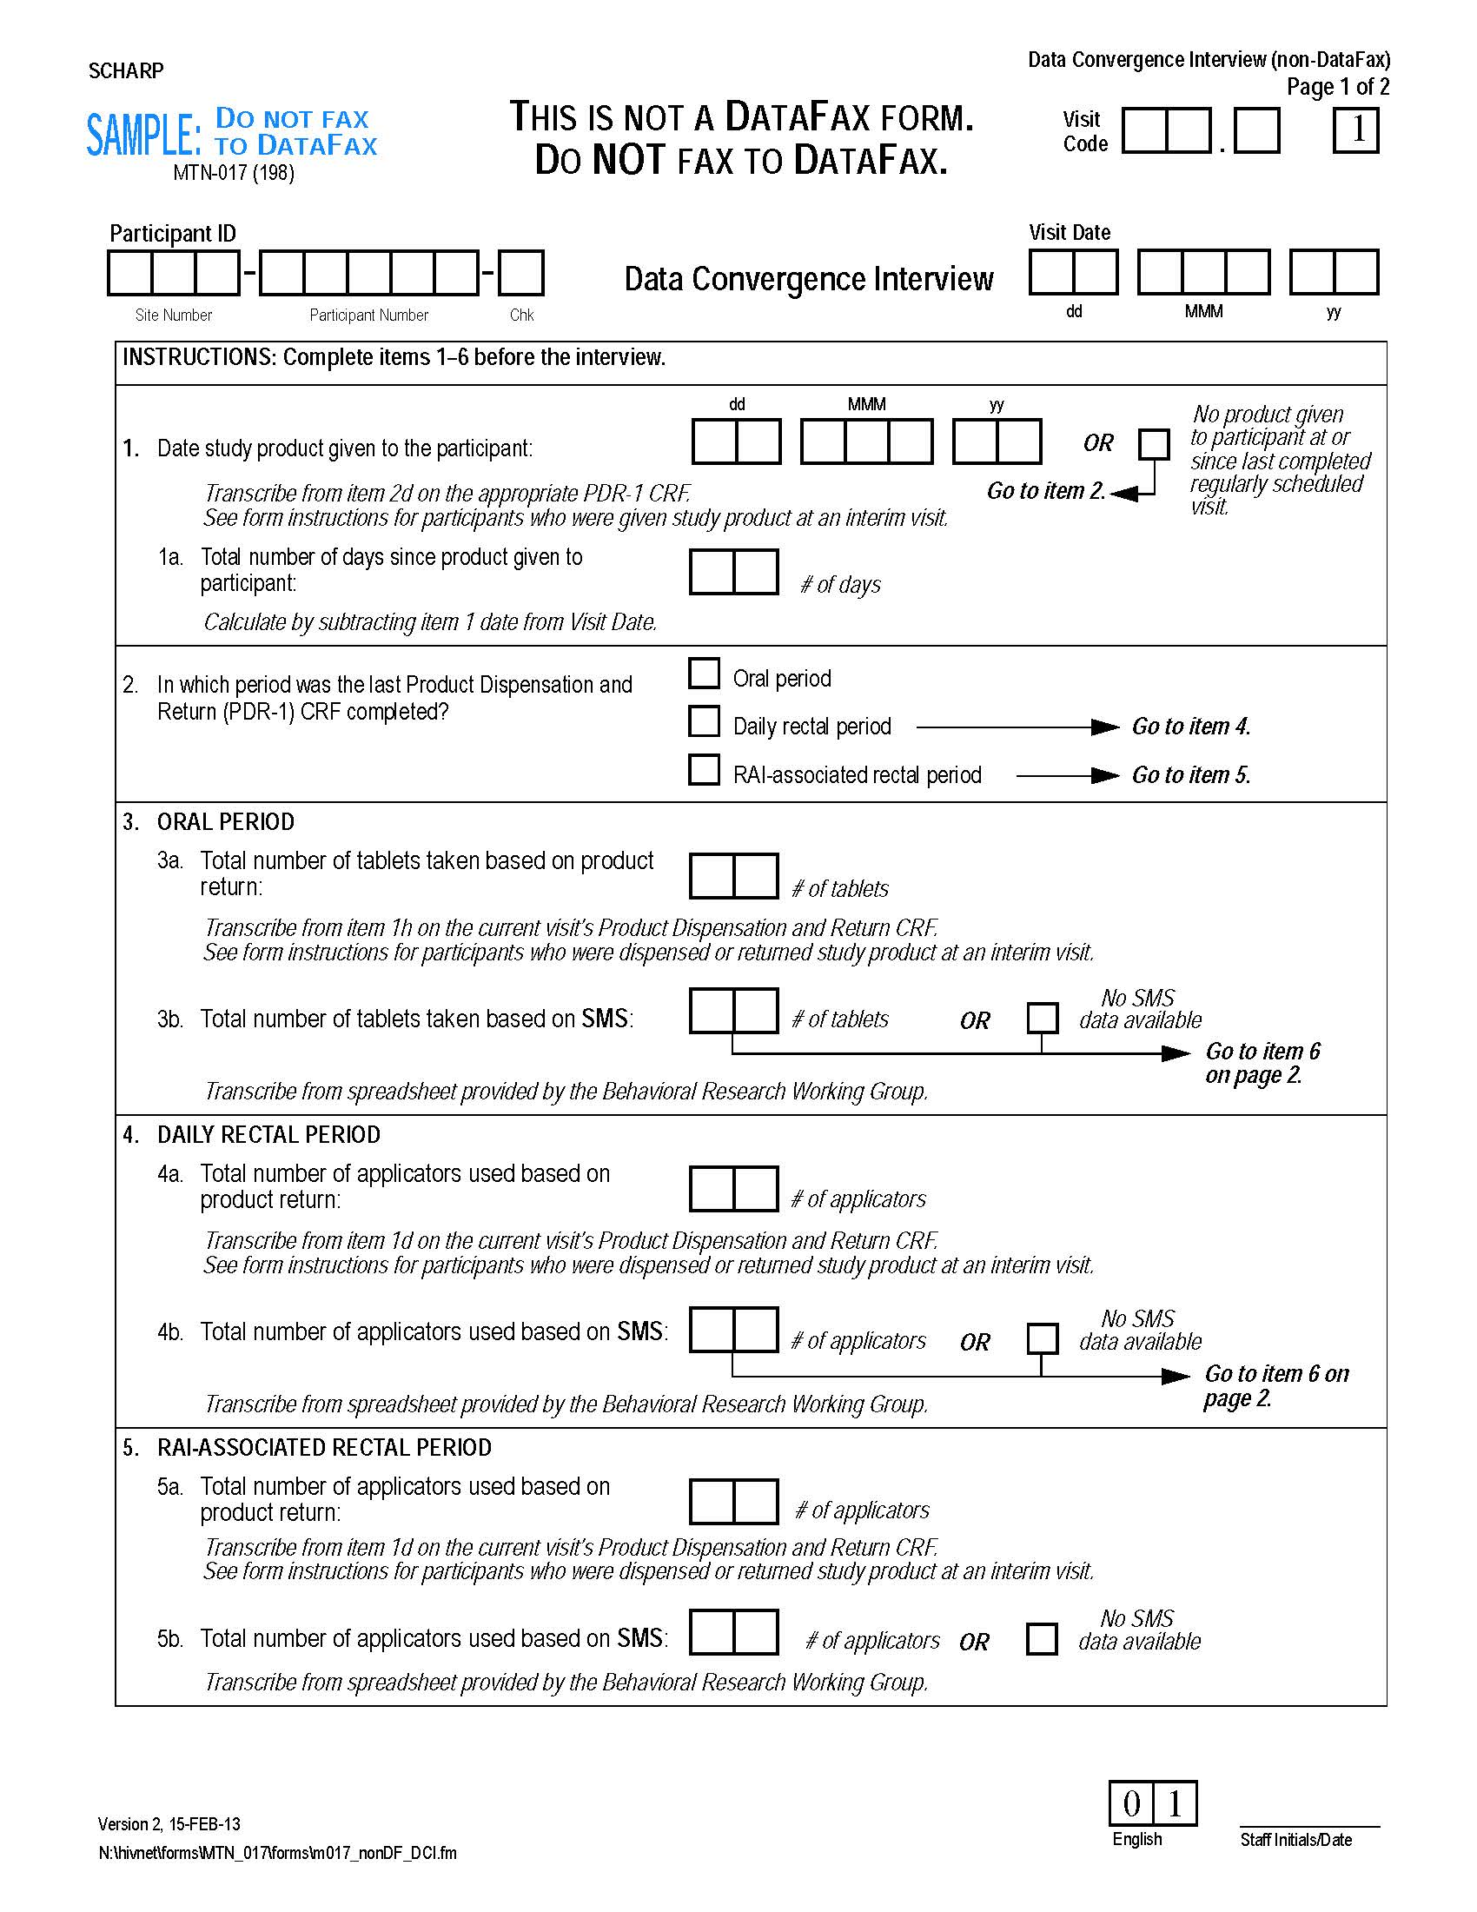

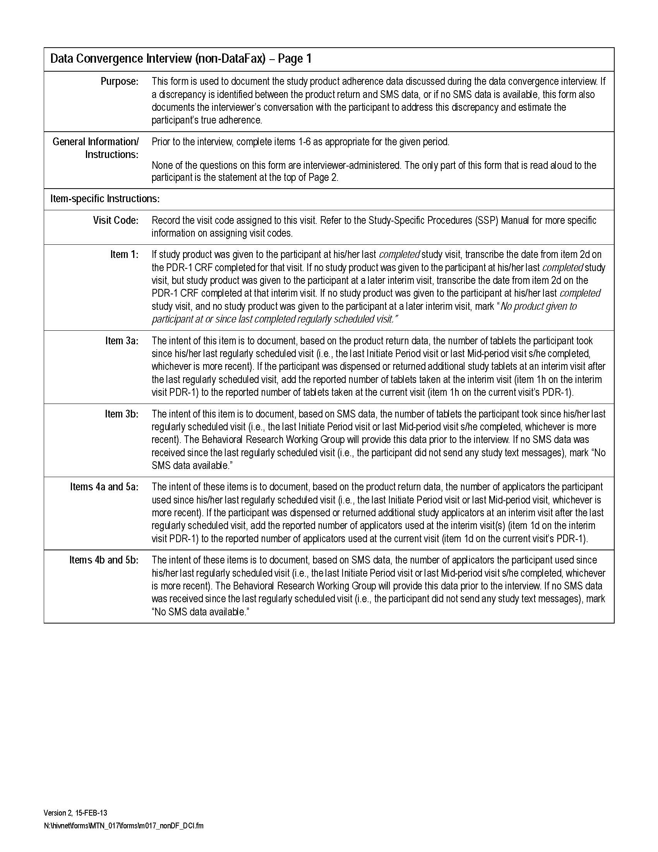

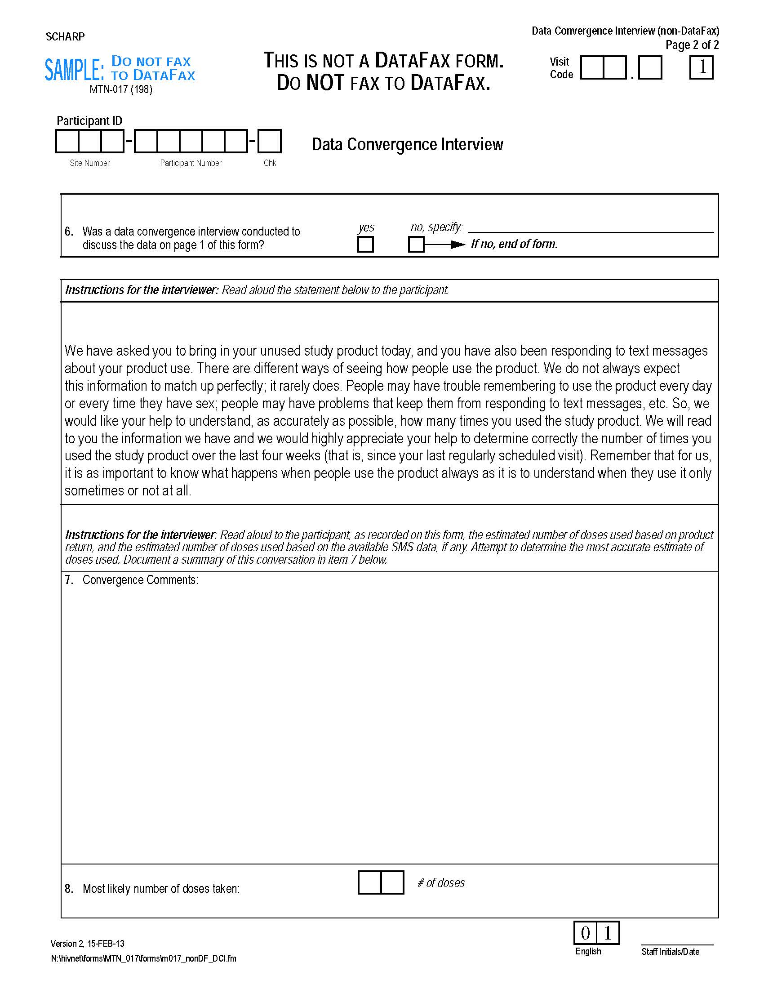

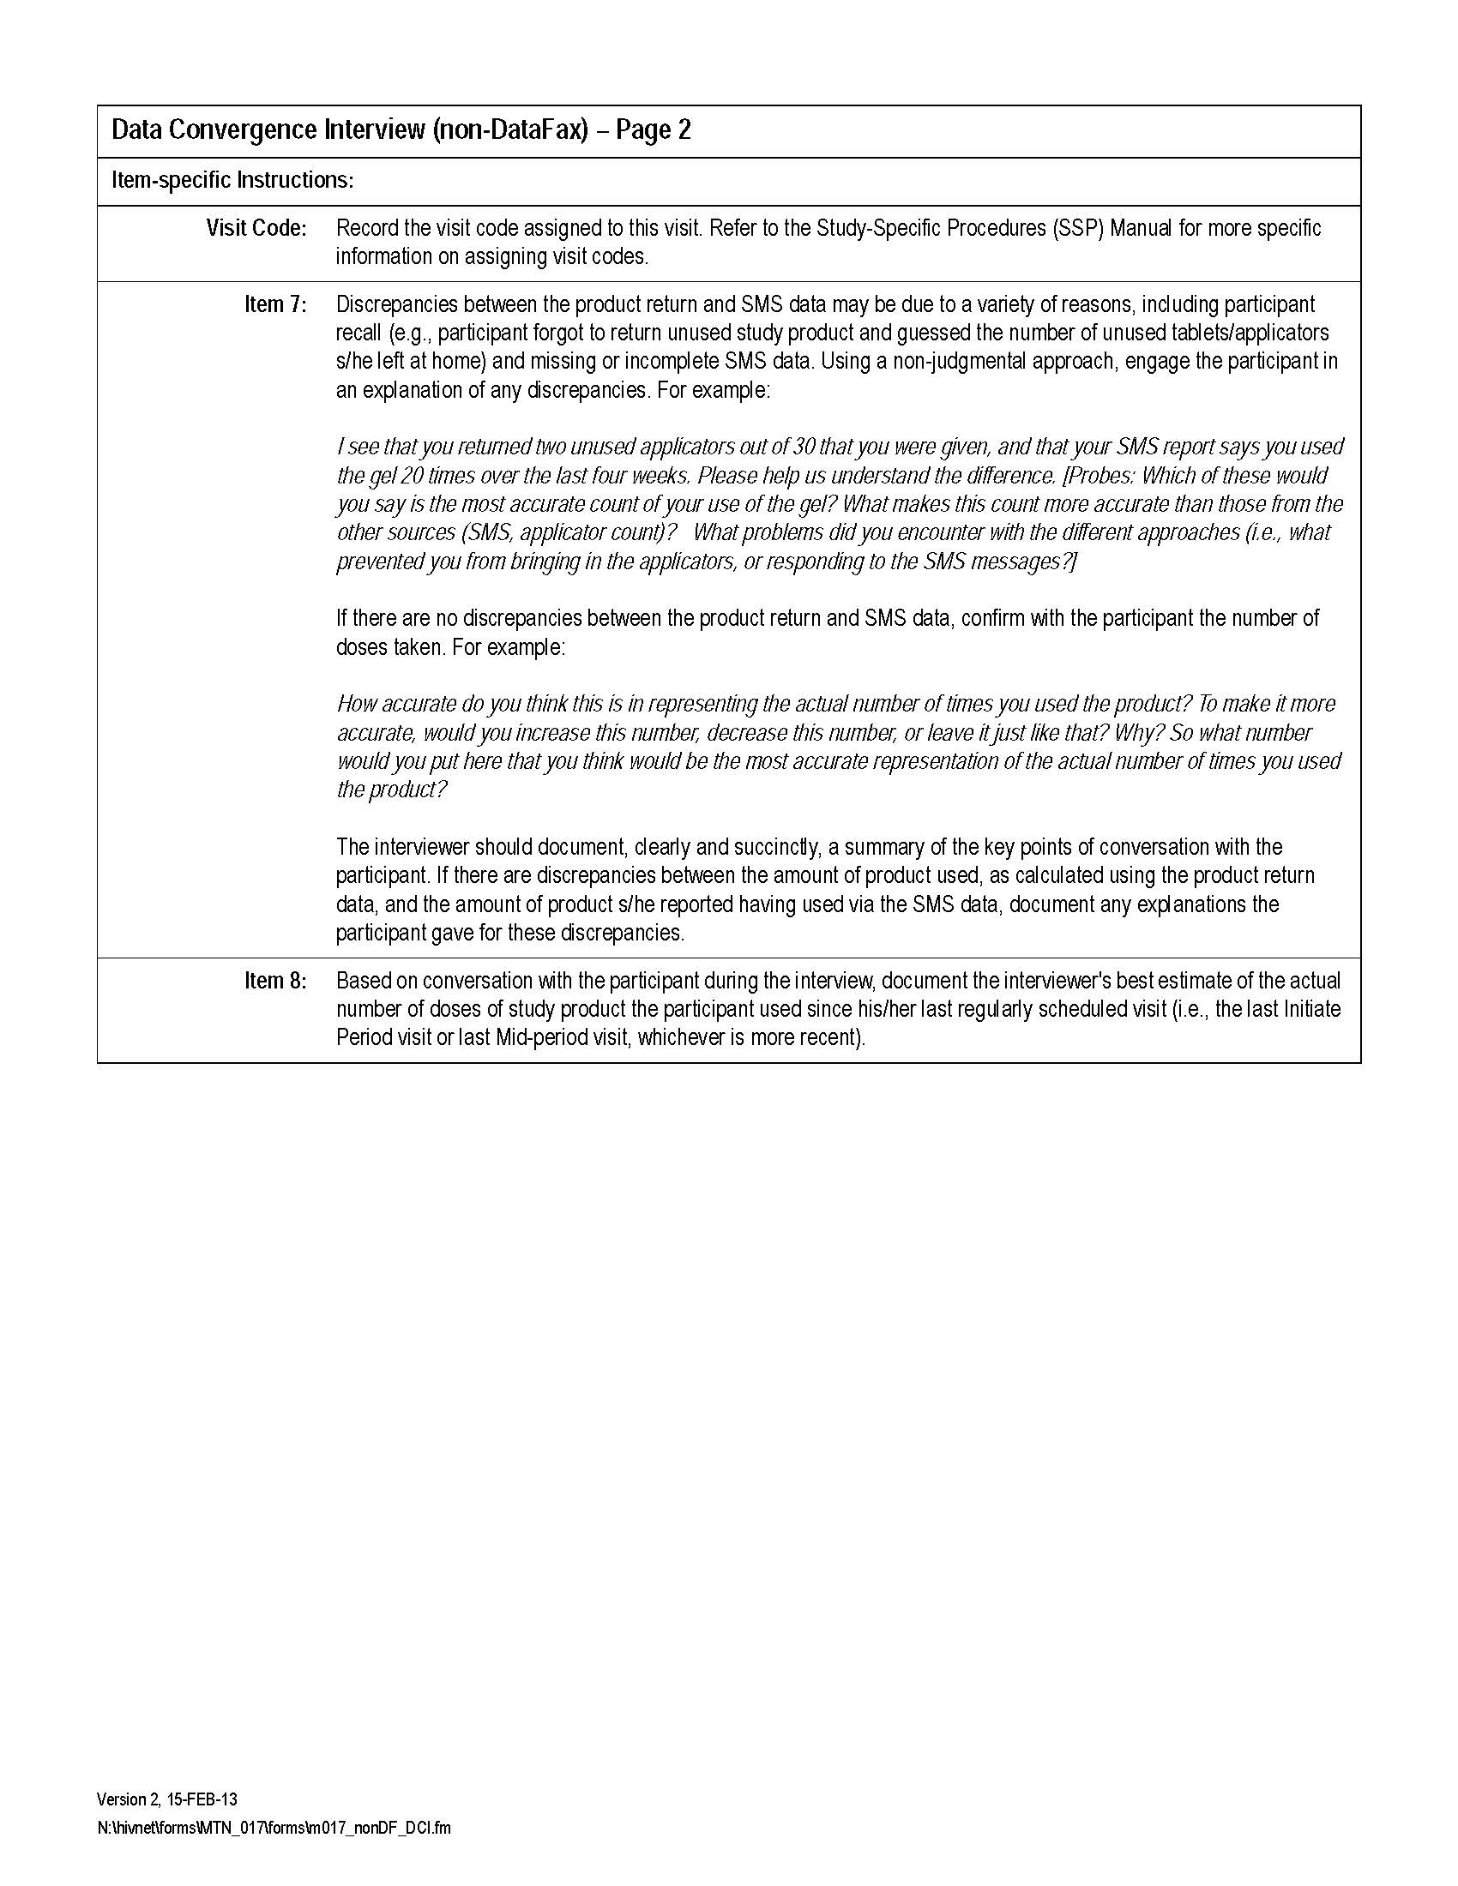

Appendix 4: Sample product use calendar

February-March | 2013

Monday | Tuesday | Wednesday | Thursday | Friday | Saturday | Sunday
February 4 | 5 | 6 | 7 | 8 | 9 | 10
11 | 12 | 13 | 14 | 15 | 16 | 17
18 | 19 | 20 | 21 | 22 | 23 | 24
25 | 26 | 27 | 28 | March 1 | 2 | 3
4 | 5 | 6 | 7 | 8 | 9 | 10
11 | 12 | 13 | 14 | 15 | 16 | 17

PTID: _________________________

Note: Calendar will include the dates of the study visits and the dates/number of times of product use for each SMS report.
Appendix 5. How am I feeling about my product use?

- I am really happy that I was able to use the product every time I had to and plan to continue that way

- I am really happy that I was able to use the product every time I had to, but that was really difficult to do and I don’t think I can keep doing that for the whole 8 weeks

- I wasn’t able to use the product every time I was supposed to and I would really like to change something so that I can use it more regularly.

- I wasn’t able to use the product like I was supposed to but this is okay because using the product was a lot more difficult than I thought, so I am comfortable with how I am using the product and I will make an effort to keep using it as frequently as I have been.

- I don’t think I can continue using the product, it has been too problematic.

- Other: _______________________________________________

Appendix 6. PK Convergence Form
For reference only! Please use original form provided by SCHARP.
